# 175 Gower Street

#### **A history**

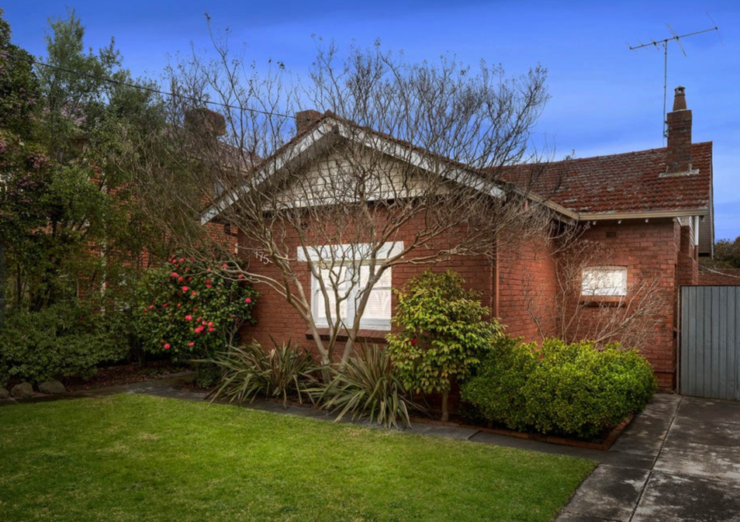

**Dr Jeska Rees, Kitchen Table Historians**

#### **December 2023**

Table of Contents

175 Gower Street 1

Gower Street, Preston 8

HP Zwar – A Preston Person 9

175 Gower Street owners, 1928-2024 10

Questions of ownership prior to 1954 10

After 1954 11

The house’s features 11

Initial design 11

Updates 13

Humans of Gower Street 15

Of further interest 15

References 17

----copyright protected content removed------

# Gower Street, Preston

Gower Street lies in an area of Preston that was farmland until well after the first World War. The road was named after the original purchaser of the allotments of the Parish of Jika Jika, Abel Gower.

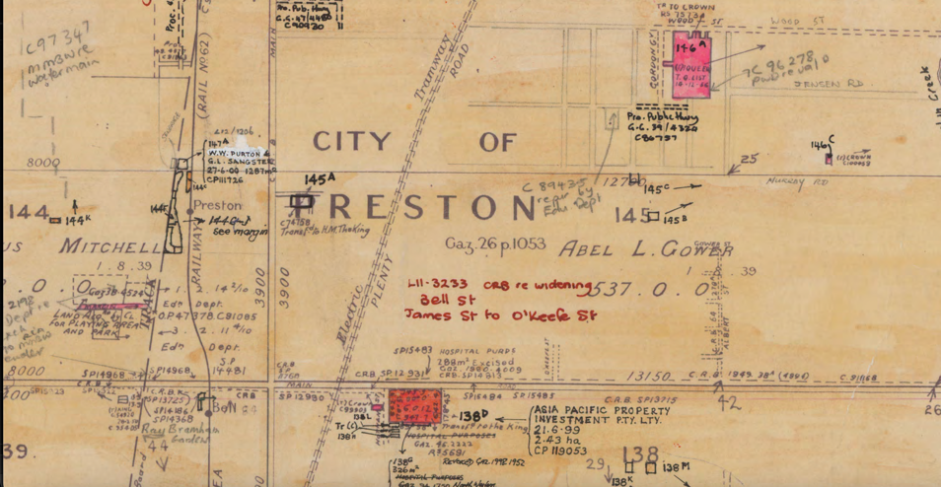

The above parish plan shows Gower as owner of 537 acres, granted on August 1, 1839.

Abel Gower did not immediately subdivide or on sell any of the land that he purchased in the Parish of Jika Jika. It was used for grazing of dairy cattle, although it is unclear whether farmers actually paid for the privilege before 1891. A thoroughfare developed travelling east-west between High Street and the Darebin Creek, which became known as Gower Street. (A later addition to the plan above, barely visible above Gower’s name, shows ‘Gower Street’ in between Murray Road and Main Road). The furthermost eastern part of this rough track was used by early settlers to collect water from the creek and so was named Water Road, a name that reamains today.

A series of farmers and dairymen do appear to have owned the eight acres that contained the present-day 175 Gower Street property, until it was sold to five businessmen in 1924.

# HP Zwar – A Preston Person

One of the businessmen who purchased the parcel of land in 1924 was Henry Zwar, the youngest of 11 children of a settler family who had arrived in Australia in 1852. Born in 1873, Zwar moved to Preston in 1911 and established a large tannery, supplying leather for car upholstery. Zwar became a leading figure in Preston, being a city councillor in 1929, a member of the Victorian Parliament in 1932 and the Mayor of Preston in 1935. He went on to become the President of the Victorian Football Association and a trustee of the Melbourne Cricket Club.

Zwar was socially minded, leading relief efforts for returned servicemen and the many affected by the Great Depression at considerable personal expense. Unverified accounts of his unpublished biography of 1949 suggest that he wrote “I paid up my overdraft only before Christmas last year after all these years and selling up my small properties to feed and clothe those families.”

Those ‘small properties’ may have included subdivided sections of the Gower Street parcel, which was subdivided into 62 separate residential titles. These small residential blocks sold steadily over at least fourteen years between 1924 and 1938, with the profits shared between the five businessmen.

# 175 Gower Street owners, 1928-2024

The future no. 175 – Lot 14 – was purchased from HP Zwar’s conglomerate in May 1928 by Leslie Ray Lucke. Lucke was a builder, and it may have been he who built the house that still stands at no.175 today.

### Questions of ownership prior to 1954

The record-keeping associated with the ownership of 175 Gower Street after its subdivision in 1924 is not always easy to decipher. The title appears to stay with Leslie Ray Lucke until 1954; however, it appears to have been mortgaged to a Mrs E Pettigrew in October 1928, five months after purchase. Mrs Pettigrew was listed as the owner of the property on the Council rate card for the years 1935-1951; a handwritten note on the card suggests that she had died by 1946, but no further updates were made as to the ownership of the site.

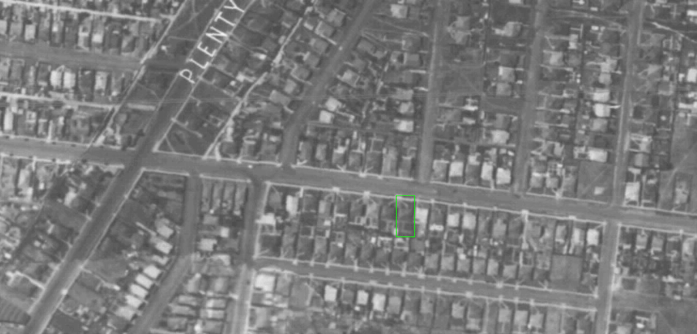

*Above: 175 Gower Street, indicated in green, in the 1945 aerial survey of Melbourne.*

### After 1954

In 1954, Jack Dowell, fitter and turner, took ownership of the title, and from here on the property changed hands at regular intervals as follows:

---------------------Content redacted for privacy reasons----------------

# The house’s features

### Initial design

The house at 175 Gower Street has many standard features for the era and yet is highly unusual in other respects. It’s likely that the house was modelled on well-known designs - some of which were used to build houses very nearby - and adjusted or adapted personally by Leslie Lucke, giving it a distinctive appearance from the street.

The design elements commonly found interwar housing include the use of double hung wooden sash windows; decorative plaster ceilings in the main rooms; small leadlight windows facing the street; and painted concrete lintels above windows and doors. The number of rooms in the house – five – in 1935 matched those of its nearest neighbours, and its position relative to the street is also the same, allowing for a side driveway and a generous front lawn.

And yet the house’s frontage is unusual. It does not feature a north-facing front veranda surrounding a front door, unlike most neighbours on the south side of the road. It has a small eastern porch covering the side entrance, limiting he opportunity to make a sitting space outside. Similarly, it has only one room facing north, a room protruding from the middle of the roofline, when much more commonplace was to have two rooms one on either side of the front door to take advantage of year-round northern sunshine. As a result of this decision the house has little natural light.

It could be that the front room is in fact a later addition, one added where the original front door and verandah might have been. However, this is unlikely: not only does the front room feature identical doorways, windows, light fittings and ceiling decoration as other original rooms, but it also appears in a Melbourne Metropolitan Board of Works map dated no later than 1930 – only two years since the property had been subdivided. Perhaps it was built this way to avoid the prospect of overheating in summer. A map of a neighborhood

Intriguingly, the above diagram features the surviving small brick structure in the south-east corner – today featuring two sections, an outdoor toilet plus a tiny room – and its plumbing, strongly suggesting that the outdoor toilet was part of the original property layout. However, the brick single-car garage does not feature and must have been a later addition.

Each of the bedrooms and the living room have common features of heavy light switches, extended internal wooden lintels over windows and lockable brass door handles, suggesting that they have not been remodelled.

### Updates

In 1954 the house was advertised as containing five rooms, although it is unclear whether such advertisements included a laundry, bathroom or toilet as a ‘room’. That said, the house does appear to have to have been internally remodelled at around this time to create an updated kitchen, bathroom and laundry, which, if the bathroom and laundry were counted, would equate to seven rooms. While the kitchen window appears to be the same age as those in the untouched living room and bedrooms, the ventilation vents either side of it have been replaced, as have the windows at the rear. The internal doors are different in style. These four-pane sparkle glass shaker doors probably date from the post-Second World War period, consistent with a date after 1954.

The bathroom and kitchen were further updated by subsequent owners in the 1980s and again in the late 2010s. However, the overall footprint of the house may not have changed since 1928.

# Humans of Gower Street

From 1928 until at least 1955 the house was rented out, with tenants either renting the entire house. or paying board for a room. Despite its modest size, 175 Gower was recorded as having six inhabitants in 1935. They may have been multiple generations of the same family. Eleanor (Nell) Hargreaves and her husband Henry lived there from sometime after 1935 with father James Carr, until James passed away in 1939. Nell and Henry continued to live there with their two children, Rob and Keith, until Henry passed away in 1951; Nell remained until 1955.

Francisco Veneziano is recorded as living in the house in 1960, and he and his wife Giuseppina purchased the house in 1967. By then, however, they were living in nearby Raglan Street, presumably renting the house out until they sold in 1975.

# Of further interest

We could ask further questions about 175 Gower Street. Urban legend has it that the celebrated Aboriginal musician Archie Roach used the backyard shed as a studio. However, no records of this have been found.

This report has not delved into the value of the property over time. The transition of this part of Preston from farmland in the 1920s to being slowly developed into residental houses during the Depression, through to the sought-after city suburb that it is today, could be readily traced through the prices paid for each successive sale of 175 Gower Street, and could be the subject of future research.

# References

#### Newspapers

*The Age*, Friday 9th October 1953, p. 4.

#### Council Records

City of Preston Rate Card, 1935-1952, no. 13033. PROV 08221/P0001; Unit 000023.

City of Preston Evaluation Register, 1967.

#### Public Records Office of Victoria (PROV)

Current land title: Volume 10575 Folio 770  
Previous land title: Volume 5448, Folio 406  
Instrument of transfer: PS435572B

#### Books

Ellender, I. and Christiansen, P., *People of the Merri Merri: the Wurundjeri of the colonial days*, Merri Creek Management Committee, 2001.

Carroll, B. and Rule, I. *Preston: an illustrated history*, City of Preston, 1985.

#### Maps

Melbourne Metropolitan Board of Works Detail plan 5070, 1 inch to 40 feet. PROV 8601/P0004 5070.

Melbourne Metropolitan Board of Works field notebooks 3301, 3434 and 3672.

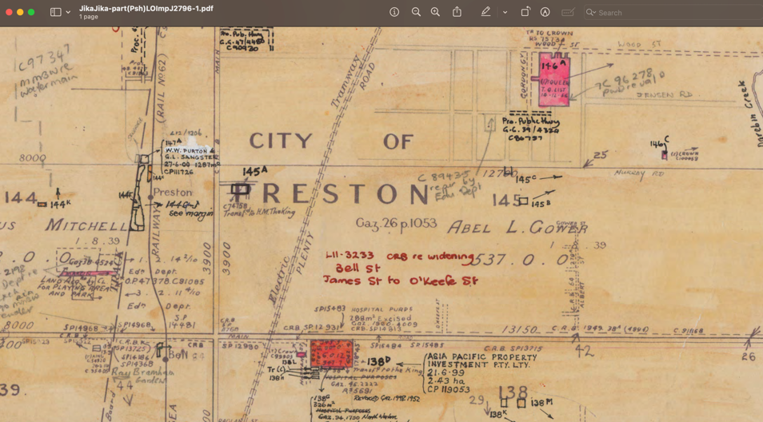

This report was compiled using publicly available information from the Public Records Office of Victoria (PROV), the State Library of Victoria, Landata, and Victoria Unearthed.

While every effort has been made to provide a complete history of 10 Elsey Road, some gaps remain. These have been noted throughout the document and summarized at the end under ‘Of further interest’.